

Internal Memorandum

**To: CIO**

**CC: n/a**

**From:** Team B

**Date:** 10/21/2018

**Memo #: 003**

**Re: Inject 003**

CIO;

Here are screenshots from all of our machines, showing the creation of a host-based firewall rule. The screenshots are sorted by IP.

* 192.168.50.201 - Ubuntu 14.04



This will block any tcp connection from 192.168.60.6 through port 22.

* 192.168.50.204 - Windows Server 2008 - A firewall rule allowing FTP and SSH, both which are scored services.

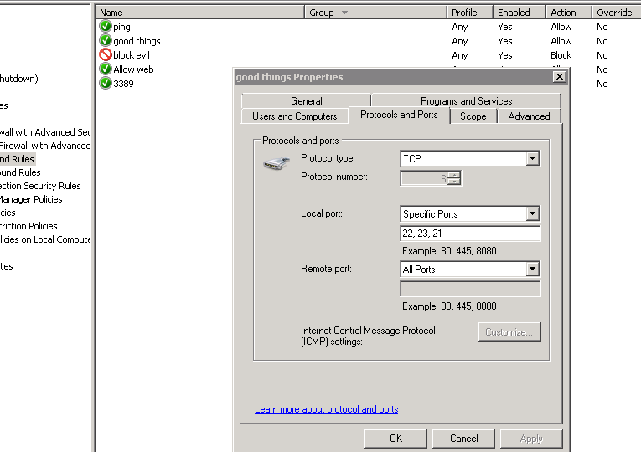

* 192.168.50.205 - Windows Server 2012

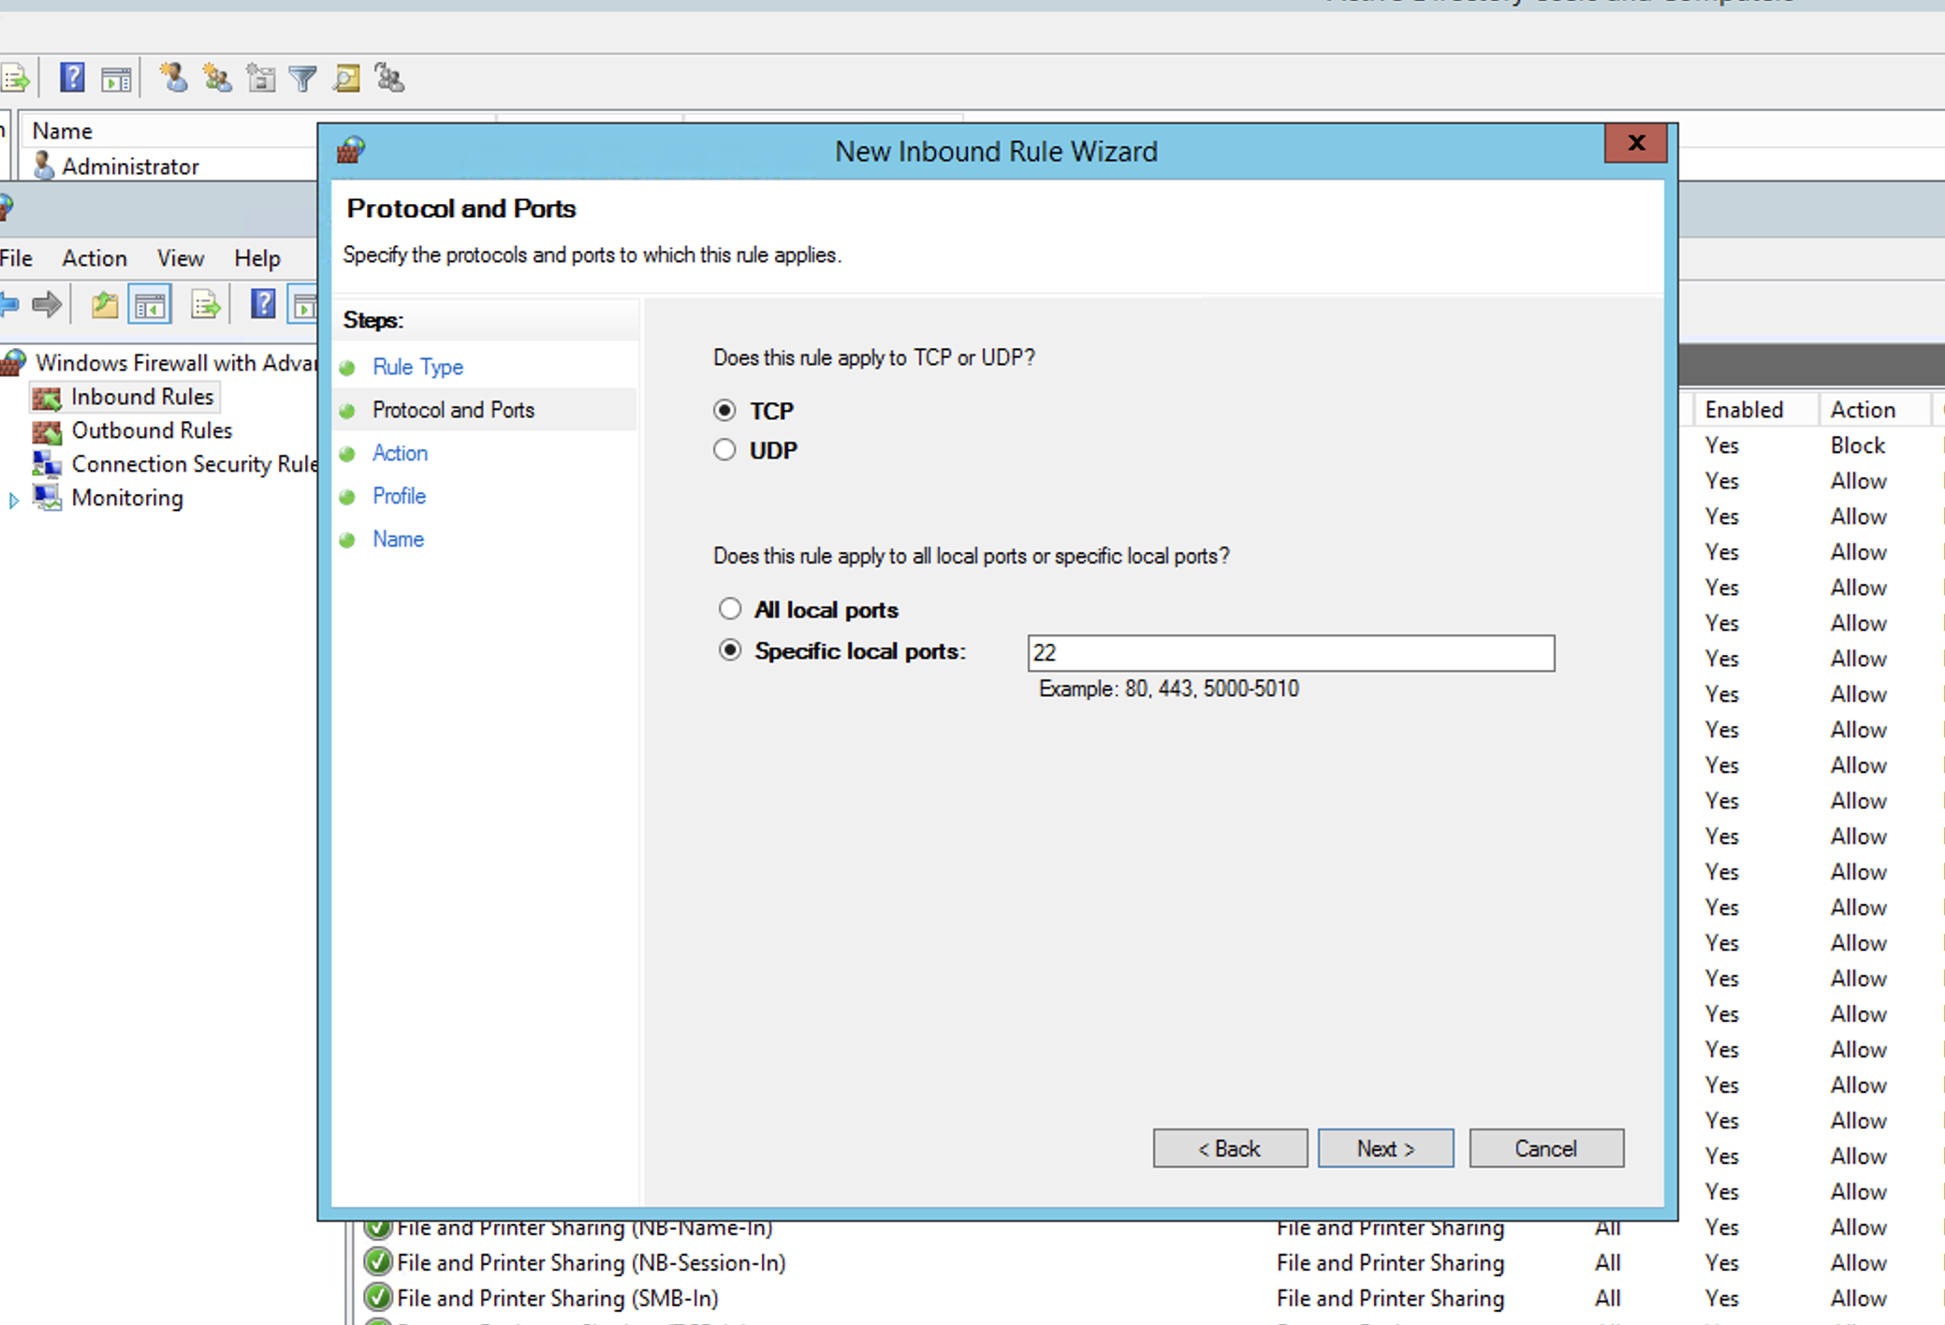

In the above screenshot a firewall rule is being created for SSH traffic on a windows host. SSH operates on port 22, so this rule allows conditions to be applied to traffic and choose to deny or accept the connection.

192.168.50.206 - Windows Server 2012

This rule will block all inbound TCP traffic coming over port 22. This would have the effect of disabling ssh connections into the server. 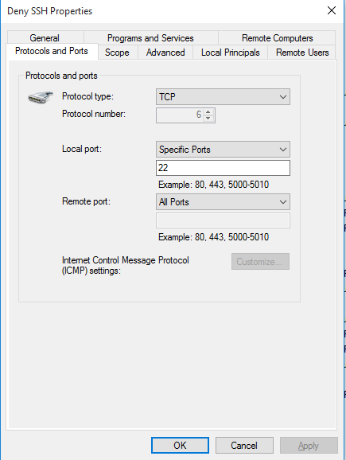



The above command shows the blocking of outbound traffic to youtube.com. Useful to prevent employees from slacking off.

192.168.50.202

iptables -I INPUT -s 192.168.60.5 -j DROP (drop all traffic from this ip)

iptables -I INPUT -s 192.168.60.6 -j DROP (drop all traffic from this ip)

iptables -I INPUT -p tcp -s 192.168.50.201 --dport 3306 -j ACCEPT (accept traffic on port 3306 only from this ip)

iptables -I INPUT -p tcp -s 192.168.50.224 --dport 3306 -j ACCEPT (accept traffic on port 3306 from this ip - add one more to the list)

iptables -A INPUT -p tcp -s 0.0.0.0/0 --dport 3306 -j DROP (and drop traffic from everywhere else on port 3306)

iptables -I INPUT -p udp -s 192.168.50.201 --dport 53 -j ACCEPT

iptables -I INPUT -p udp -s 192.168.50.224 --dport 53 -j ACCEPT (allow only 2 ip’s to access udp port 53)

iptables -A INPUT -p udp -s 0.0.0.0/0 --dport 53 -j DROP (and drop traffic from everywhere else on port 53 dns)

*In accordance with HAL Memorandum policy, the entire header must be completed or the recipient may not acknowledge this as an official memorandum. Professional communications methods and decorum must be observed at all times.*